# **OPERATING SYSTEM**

# **EXPERIMENT 12**

# **SEMAPHORE**

# **Submitted by: -**

# **Ayushi Kumari**

# **RA1911003010865**

1. **Producer/Consumer’s Problem-**

**Code-**

#include<stdio.h>

#include<stdlib.h>

int mutex=1,full=0,empty=3,x=0;

int main()

{

int n;

void producer();

void consumer();

int wait(int);

int signal(int);

printf("\n1.Producer\n2.Consumer\n3.Exit");

while(1)

{

printf("\nEnter your choice:");

scanf("%d",&n);

switch(n)

{

case 1:if((mutex==1)&&(empty!=0))

producer();

else

printf("Buffer is full!!");

break;

case 2:if((mutex==1)&&(full!=0))

consumer();

else

printf("Buffer is empty!!");

break;

case 3:

exit(0);

break;

}

}

return 0;

}

int wait(int s)

{

return (--s);

}

int signal(int s)

{

return(++s);

}

void producer()

{

mutex=wait(mutex);

full=signal(full);

empty=wait(empty);

x++;

printf("\nProducer produces the item %d",x);

mutex=signal(mutex);

}

void consumer()

{

mutex=wait(mutex);

full=wait(full);

empty=signal(empty);

printf("\nConsumer consumes item %d",x);

x--;

mutex=signal(mutex);

}

**Output-**

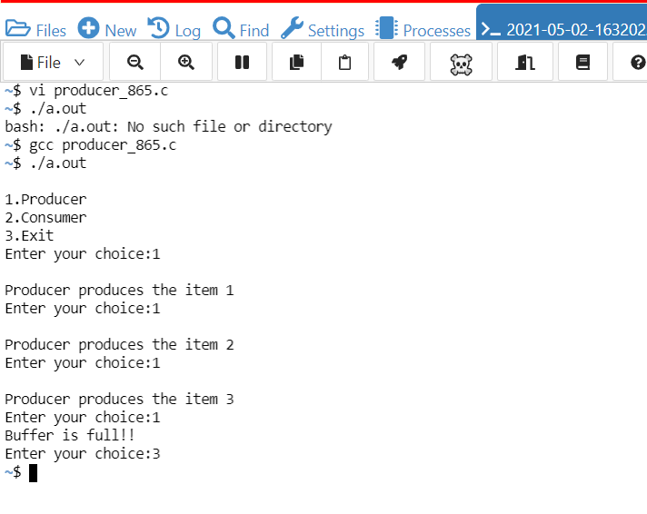

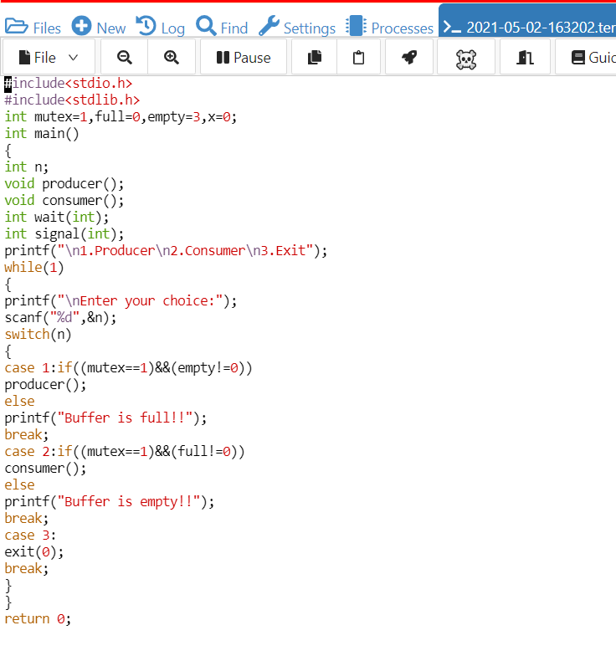

1. **Dining philosopher’s Problem-**

**Code-**

#include <pthread.h>

#include <semaphore.h>

#include <stdio.h>

#define N 5

#define THINKING 2

#define HUNGRY 1

#define EATING 0

#define LEFT (phnum + 4) % N

#define RIGHT (phnum + 1) % N

int state[N];

int phil[N] = { 0, 1, 2, 3, 4 };

sem_t mutex;

sem_t S[N];

void test(int phnum)

{

if (state[phnum] == HUNGRY

&& state[LEFT] != EATING

&& state[RIGHT] != EATING) {

state[phnum] = EATING;

sleep(2);

printf("Philosopher %d takes fork %d and %d\n",phnum + 1, LEFT + 1, phnum + 1);

printf("Philosopher %d is Eating\n", phnum + 1);

sem_post(&S[phnum]);

}

}

void take_fork(int phnum)

{

sem_wait(&mutex);

state[phnum] = HUNGRY;

printf("Philosopher %d is Hungry\n", phnum + 1);

test(phnum);

sem_post(&mutex);

sem_wait(&S[phnum]);

sleep(1);

}

void put_fork(int phnum)

{

sem_wait(&mutex);

state[phnum] = THINKING;

printf("Philosopher %d putting fork %d and %d down\n",phnum + 1, LEFT + 1, phnum + 1);

printf("Philosopher %d is thinking\n", phnum + 1);

test(LEFT);

test(RIGHT);

sem_post(&mutex);

}

void* philospher(void* num)

{

while (1) {

int* i = num;

sleep(1);

take_fork(*i);

sleep(0);

put_fork(*i);

}

}

int main()

{

int i;

pthread_t thread_id[N];

sem_init(&mutex, 0, 1);

for (i = 0; i < N; i++)

sem_init(&S[i], 0, 0);

for (i = 0; i < N; i++) {

pthread_create(&thread_id[i], NULL,philospher, &phil[i]);

printf("Philosopher %d is thinking\n", i + 1);

}

for (i = 0; i < N; i++)

pthread_join(thread_id[i], NULL);

}

**Output: -**

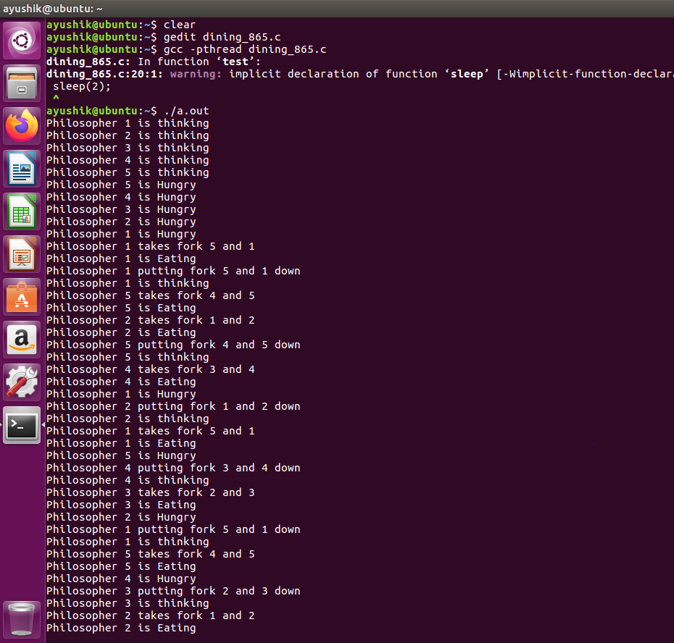

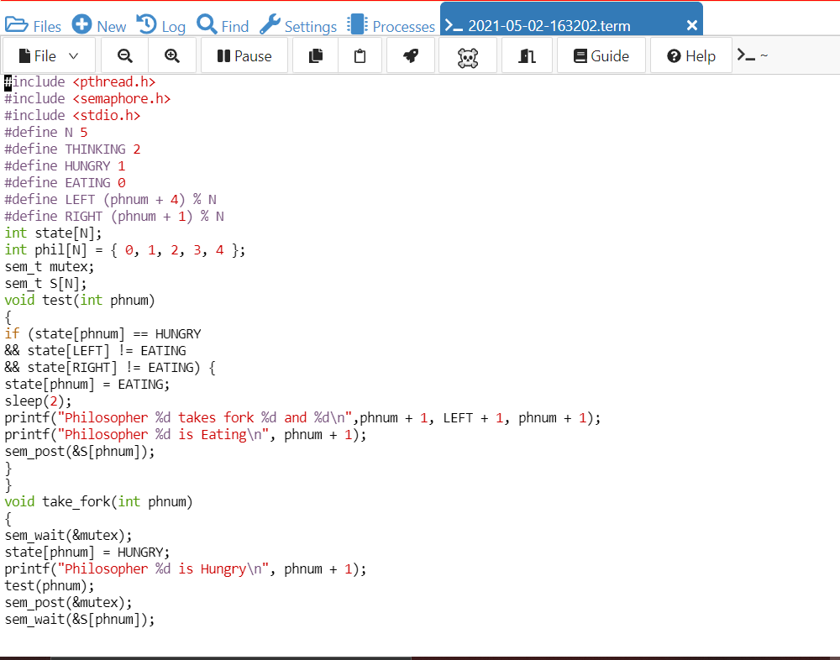

**---------------------------X--------------------------**